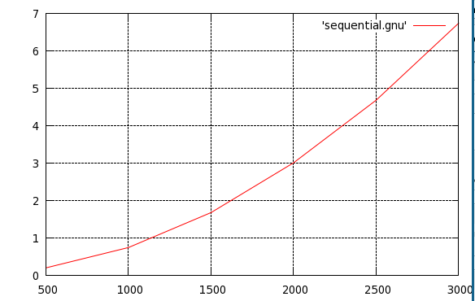
Figure 1) Time in seconds (y-axis) vs. size of board (x-axis) of the Sequential implementation of the Game of Life. Total Number of Steps = 10 Run on dione00.

# Gnu time to complete computation vs. size of board
500 0.203203
1000 0.747008
1500 1.68051
2000 3.01181
2500 4.68525
3000 6.7439

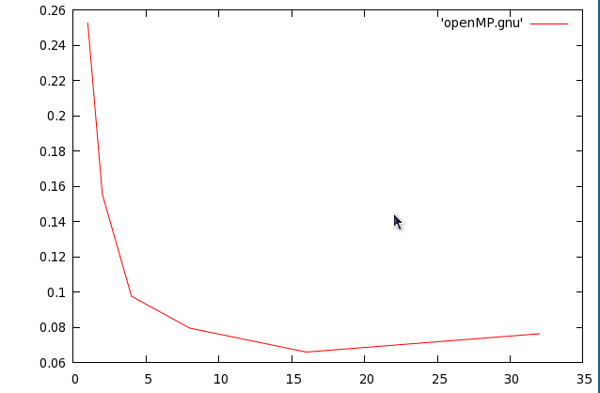
Figure 2) Time in Seconds vs number of threads working on a size 500 randomly generated game of life board. 10 steps. Computed on dione00.

#Gnu Plot of number of strings vs. Time in Open_MP implementation
1 0.252663
2 0.155512
4 0.0976179
8 0.079519
16 0.0659399
32 0.0763321

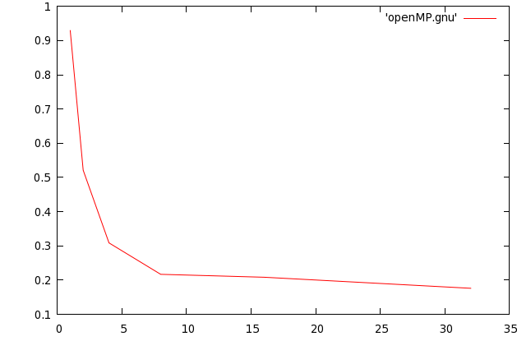
Figure 2) Time in Seconds vs number of threads working on a size 1000 randomly generated game of life board. 10 steps. Computed on dione00.

#Gnu Plot of number of strings vs. Time in Open_MP implementation
1 0.929191
2 0.52124
4 0.308823
8 0.217014
16 0.2085
32 0.176161

